Individual Project Report

*Name*: Varun Burde (burdeva1@fel.cvut.cz)

*Course*: Individual Project BE3MPROJ8

*Supervisor*: Ing. Michal Reinštein Ph.D. (reinstein.michal@fel.cvut.cz)

*Title*: Deep neural network for classification and segmentation of Google StreetView imagery

February 2019

# **Abstract**

With the advancement computation power and large datasets finally made a huge improvement of Deep neural network leading many widespread applications. One of such application is solving computer vision problems like classification and segmentation. Also Competition like ImageNet[1] Large Scale Visual Recognition Challenge, took the solution to next level, in some cases classification is better than Human.

This report describes the evaluation of pre-trained deep neural network on Google StreetView Images[2]. Pretrained model used are Mask RCNN[3], Xception[4] , VGG16[5], VGG19[5], Inception v3[6], Inception resnetv2[7], Resnet50[8], MobileNet[9], MobileNetv2[10], DenseNet[11], NASNet[12]. Implementation is done in Python[13] using Keras[14] and TesnsorFlow-GPU[15] framework. User interface for the application execution, processing of the input images and visualization of the results is realized using Google Colab[16] with repository in GIT[17].

A pipeline was created for the task, user provide the parameters like coordinates, heading, field of view for the Google StreetView API [2]. Python[13] script downloads the available images to that location then images were preprocessed to fit into classifier. Classification is done on the Images depending on the architecture of the Neural Network.

The classification results were evaluated based experiment taking downloading images from three random location inside Prague with specific parameters like resolution, field of view etc. The recognition of misclassification of object is evaluated by human sense and presented in below evaluation section.

Since the different types of network have different architecture and detection algorithm, it wasn’t possible to have direct comparison between them , so detection is done with two separate section one with Mask R-CNN[3] and other with all pretrained model available in Keras[14], but with same images from Google StreetView[2].

# **Acknowledgement**

I would like to acknowledge the help of all of those which made this project possible. I would like to express my deep gratitude to my supervisor **Ing. Michal Reinštein, Ph.D** , for his time ,patience, guidance and also for allowing the idea to be persuaded originally, and made this project successful. I would also like to thank Jana Zichová who let me to register for this project.

Furthermore, I would like to thank to all those people who works on all open source projects mentioned in reference, and all wonderful people who post the discussion and blogs for all useful learning resources, specially to Stanford open course CS231n: Convolutional Neural Networks for Visual Recognition which. I am also thankful for Google free resources like Google Collab laboratory and Street View API which made the project possible.

**Contents**

**Abstract** 2

**Acknowledgement** 3

**1.** **Introduction** 6

I. Aims and objective of the Project 6

II. Overview of the project progress 6

1. Google Street View API: 6

2. Classification 6

III. Some important topics 6

Image Classification: 6

Semantic Segmentation: 7

Instance segmentation 7

Keras 8

Tensorflow 9

Pre-trained models in Keras 9

List of Pre-trained models used in Project for classification were following 9

Google Colab 11

Mask R-CNN 11

IV. Problems faced during project 12

**2.** **Related Work** 14

1. Layered Interpretation of Street View Images[33] : 14

2. Building Instance classification using street view images [34] 14

**1.** **Implementation** 15

Pipeline 15

Download the required libraries 15

Google Street view Api 15

Prepare the model 17

Define or import helper function 17

Preprocess the Image 17

Fit into classifier and predict the result 18

Visualize the result 18

**2.** **Evaluation** 20

**3.** **Future Scope** 27

**4.** **Conclusions** 28

**5.** **References** 29

**6.** **Appendix A** 31

**7.** **Appendix B** 59

**List of Figures** 65

# **Introduction**

## Aims and objective of the Project

The aim is to design and implement deep neural network-based solution for online semantic segmentation of Google StreetView images[2]. The proposed software solution should allow the user to request Google StreetView[2] imagery for any given location and output scene description as a list of detected objects (with confidences) and pixel-wise scene segmentation mask. User interface for the application execution, processing of the input images and visualization of the results should be realized using Google Colab[16] and should be easily executable (handling required packages and dependencies on code repositories). Pre-trained existing models should be explored first, thorough experimental evaluation on publicly available datasets should follow. Comparison with related state-of-the-art work is integral part of the project and should be presented in the final report. Recommendation: implementation should be done in Python[13], using Keras[14] and TensorFlow[15] frameworks.

The product of the project will be the software solution which will get the classification of the objects from google street images specified by the user in parameter like coordinates, field of view etc.

## Overview of the project progress

The software solution was developed in small steps to fulfil the required results and aim, and easy to debug. Project was spilt in two parts which were developed independently

1. Google Street View API: The use of API to download the proper sensible Images for classification need the proper parameters values to download Images which will lead good results and proper use of software solution.
2. Classification :The use of the pre trained model and tweaking the parameters like confidence threshold which will allow to software solution to generate the instance segmentation [18] of each images download with different color mask on each detected object with their confidence. The detected objects will have bounding boxes with class names and the colored pixel wise segmentation mask.

## Some important topics

Image Classification: It is a topic of pattern recognition in computer vision, is an approach of classification based on contextual information in images. "Contextual" means this approach is focusing on the relationship of the nearby pixels, which is also called neighborhood. The goal of this approach is to classify the images by using the contextual information[19].This relationship of nearby pixel is calculated using classifiers, one of the example is to use nearest neighbor classifier in which pixel -wise absolute value differences can be use to show relationship between test and train image[20].Below Image is example in which object is classified as the predefined class car with confidence of 0.98.

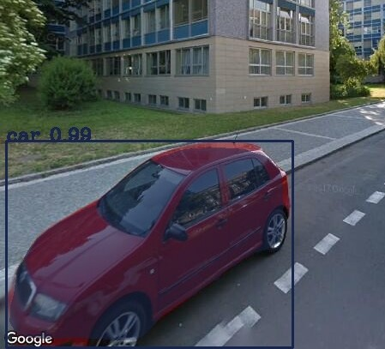

Figure 1 Example of Image classification

Semantic Segmentation: In computer vision, Image segmentation is process of partitioning of digital image into multiple segment. Segmentation has two objectives. The First objective is to decompose the image into parts for further analysis the second objective of segmentation is to perform a change of representation. The pixels of the image must be organized into higher-level units that are either more meaningful or more efficient for further analysis (or both)[21].

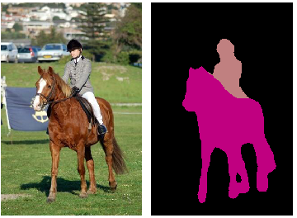

Figure 2 Example of Image segmentation source:[22]

Instance segmentation: It is instance-wise semantic segmentation and a segmentation approach to classify a single mask based on a proposal object [23].

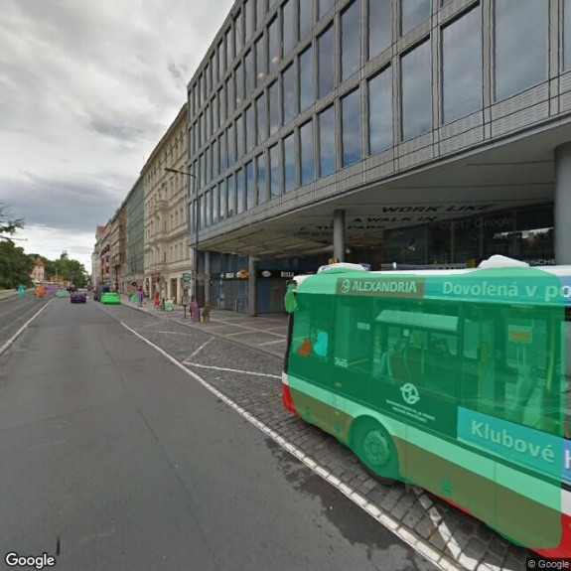

Figure 3 Instance Segmentation

The above image is example of instance segmentation of with different color segmentation masks. For ex In Figure 5 the bus is segmented with green mask.

### Keras

Keras is a high-level neural networks API, written in Python and capable of running on top of TensorFlow, CNTK, or Theano. It was developed with a focus on enabling fast experimentation. Being able to go from idea to result with the least possible delay is key to doing good research.[14]

For the usage in project, it allows user to use the model of different architecture just by defining class and pretrained weights in arguments. For the purpose of project pretrained weights which were trained in ImageNet[1] database were used . There are total of 1,281,167 images for training. The number of images for each (category) ranges from 732 to 1300. There are 50,000 validation images, with 50 images per category. There are 100,000 test images. All images are in JPEG format.

Also, it has support for CPU and GPU as well TPU in case we use Google Colab. It’s a powerful library with lots of option in tweaking the parameter of layer, loss functions etc.Below Image is example of how to make a model class in python using the Imagenet weights.

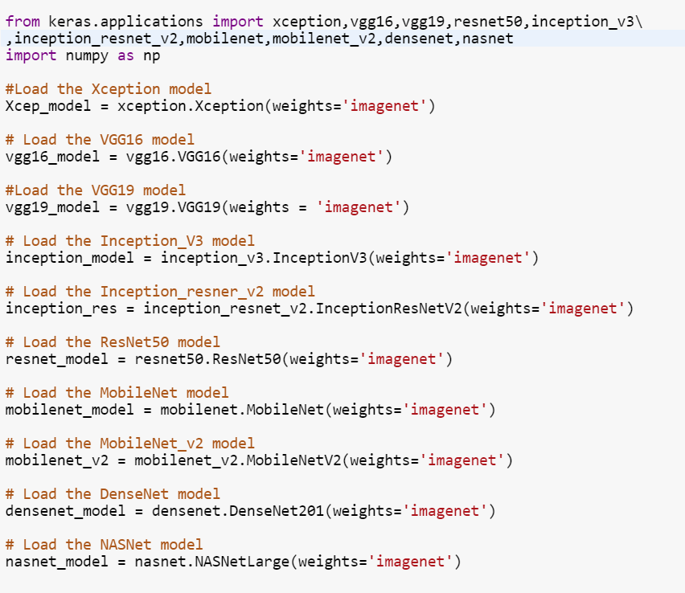

Figure 4 Loading of Different models in Keras

### Tensorflow

TensorFlow is an interface for expressing machine learning algorithms, and an implementation for executing such algorithms. A computation expressed using TensorFlow can be executed with little or no change on a wide variety of heterogeneous systems, ranging from mobile devices such as phones and tablets up to large-scale distributed systems of hundreds of machines and thousands of computational devices such as GPU cards. For the purpose of project TensorFlow GPU backend is used to do all the computation to accelerate the progress cause its highly compatible with the Google colab[16] and Keras [14].

### Pre-trained models in Keras

### List of Pre-trained models used in Project for classification were following

#### vgg16 and vgg19

The 16 and 19[5] stands for number of weight layer in the network. Due to its depth and fully connected it was hard to train the network. To make training easier it should be trained less weight layer first and then after smaller converged network can be used as Initializer for the larger deeper network and process was called Pre-training. It was the winner 1st runner up for image classification and winner of localization in ILSVRC 2014[24].

#### Resnet50

Resnet 50 [8] ,In general convolution network several layers are stacked and are trained to for feature filter layer by layer. In residual learning, network will try to learn the residual, Residual is the subtraction of feature learned from the input of the layer. Its architecture is based on micro -architecture which have small building blocks which can be used to construct the network. The collection of micro-architecture building block leads to macro architecture. Its performance was outstanding being the winner of ILSCRC[1] 2015 (Image Classification, Localization ,Detection)

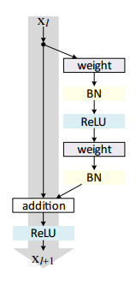

Figure 5 Micro Architecture of Resnet50 source [25]

#### inception_v3

The Inception v3[7](1st runner up Image Classification ILSVRC[1] 2015) model make multi- level feature extractor by computing 1x1, 3x3 and 5x5 convolution within the same module of the network and output of these filters are stacked along the channel dimension before being fed into the next layer in next layer.

#### Xception

Xception[4] was proposed by Feancois Chollet the creator of Keras Library. It is an extension of Inception architecture which replaces the standard Inception modules with depth wise separable convolution. It was found to perform better than Inception v3[7] for Image classification.

#### mobilenet_v2

The purpose of mobile net was to have general purpose computer vison neural network for mobile devices in mind to support classification, detection and more. Mobile net v2 introduces two new features to architecture 1) linear bottleneck between layers and 2)shortcut connection between the bottleneck.[10]. Its light weight model as compared to other pervious model [4], [5], [7], [11]and needs low computing power.

#### Densenet

Densely convolution network [11]which connect each layer to every other layer in feed-forward fashion. Tells convolution network can be substantially deeper, more accurate and efficient to train if they contain shorter connections between layers close to the input and those close to the output.

#### Nasnet

Google introduced "AutoML" that automates the design of machine learning model, a controller neural net can propose a “child” model architecture, which can then be trained and evaluated for quality on a task. That feedback is then used to inform the controller how to improve its proposals for the next round. We repeat this process thousands of times — generating new architectures, testing them, and giving that feedback to the controller to learn from. With this method, AutoML was able to find the best layers that work well on CIFAR-10 but work well on ImageNet classification and COCO object detection. These two layers are combined to form a novel architecture, which called “NASNet”[12]

### Google Colab

It’s a free research tool for machine learning education and research tool which uses Jupyter[26] notebook Environment which can be run maximum of 12 hours in single runtime. Which can be useful in evaluation and testing cause of high-end Hardware but on the other side makes it not proper tool for training of Neural network.

Google colab[16] have support for deep learning application like Keras[14],TensorFLow[15] ,Pytorch[27] and Opencv[28] .This make task easier and save time for installation and configuration of all libraries .Also the other dependencies could be easily installed using pip installer .

It also allows 3 different kind of runtime Hardware’s like GPU, CPU and TPU which can accelerate the process. It just needs little changes from the developed code in local machine to work in Colab.

### Mask R-CNN

Mask R-CNN[3] is state of the art convolution Neural network which can do Instance segmentation. We start with Faster R-CNN[29] .It consist of two stages the first Region proposal Network(RPN) stage scans the image and generates proposals (areas likely to contain an object) and other stage which is essence of fast R-CNN[30] classifies the proposals and generates bounding boxes and masks.

Anchors are the fixed bounding boxes of defined shape and sizes which are places into images which will be used for reference when localizing the object in the image.

Region Proposal Network A Region Proposal Network (RPN) takes an image (of any size) as input and outputs a set of rectangular object proposals, each with an object score with the help of anchors. The offsets of the image from the anchors is taken as input and propose an object location in Image.

Second stage of feature extraction extracts features using RoIPool from each candidate box and performs classification and bounding-box regression. Output of Regression gives determines the a predicted bounding box in form of x,y,w,h (x coordinate , y coordinate , width ,height ) and output of classification is a probability whether the predicted bounding box contain an object or not.

Along with these two stages, In second stage of Mask R-CNN in parallel to predicting he class and box offset it also outputs a binary mask for each Region of Interest

Bilinear interpolation is an extension of linear interpolation for interpolating functions of two variables[31].

Roi Align: RoIPool [30]is a standard operation for extracting a small feature map from each RoI. RoIPool first quantizes a floating-number RoI to the discrete granularity of the feature map, this quantized RoI is then subdivided into spatial bins which are themselves quantized, and finally feature values covered by each bin are aggregated (usually by max pooling). In each ROI bin, the value of the four regularly sampled locations are computed directly through bilinear interpolation. Thus, avoid the misaligned problem.

Network Architecture: Mask R-CNN have multiple architecture 1) Convolution backbone architecture used for feature extraction over an entire image and 2) network head for bounding box recognition(classification and regression) .

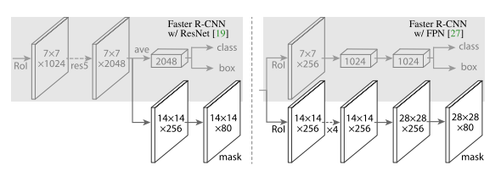

Figure 6 Head Architecture of Mask R-CNN source [3]

Backbone: Its standard convolution network that serve as feature extractor, convolution network Resnet50 with the introduction of Feature Pyramid Network [32].

Feature pyramid Network: The Feature Pyramid Network (FPN) was introduced in Mask R-CNN as an extension that can better represent objects at multiple scales. FPN improves the standard feature extraction pyramid by adding a second pyramid that takes the high-level features from the first pyramid and passes them down to lower layers. By doing so, it allows features at every level to have access to both, lower and higher-level features.

## Problems faced during project

The problems which were faced during the evaluation

1. Improper downloaded Images: Even though setting up the perfect parameters for the best images to download there were some glitches in picture. Sometimes lead to poor results for instance, below image is example of one it, though the glitch wasn’t classified in this image, but it can be possible to get detection of it. It is due to slow stutter speed of camera during capture of fast vehicle which was recognized after investigating the more images around it .

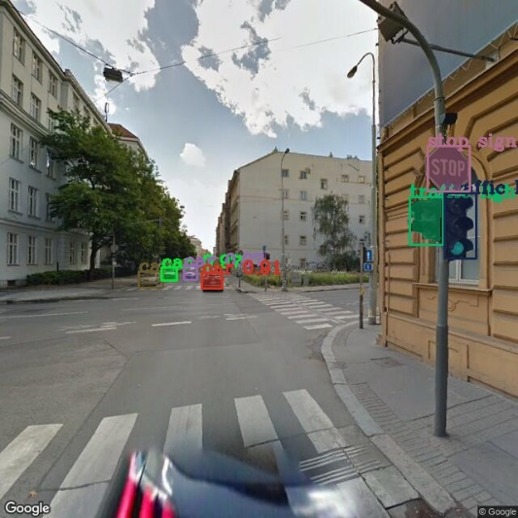

Figure 7 Glitches in google Images

1. Tweaking the parameter of Model: To get optimum results in classification based on personal Human sense. The parameters of like confidence threshold, strides, Pool size etc. should be set. Example of such as detection of object with confidence of .5 cat given Below

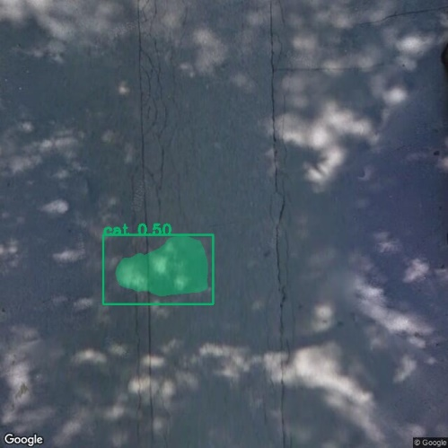

Figure 8 unproper results without proper parameter values

# **Related Work**

1. Layered Interpretation of Street View Images[33] :

Proposed a layered street view model to encode both depth and semantic information on street view images for autonomous driving. They propose a 4-layer street view model, layers encode semantic classes like ground, pedestrians, vehicles, buildings, and sky in addition to the depths. The only input to our algorithm is a pair of stereo images. Deep neural network was used to extract the appearance features for semantic classes.

## Building Instance classification using street view images [34]

Land-use classification based on spaceborne or aerial remote sensing images has been extensively studied over the past decades. Proposed a general framework for classifying the functionality of individual buildings. The proposed method is based on Convolutional Neural Networks (CNNs) which classify façade structures from street view images, such as Google StreetView[2], in addition to remote sensing images which usually only show roof structures. Geographic information was utilized to mask out individual buildings, and to associate the corresponding street view images. In addition, the method was applied to generate building classification maps on both region and city scales of several cities in Canada and the US

# **Implementation**

As mentioned before introduction, project is done is small steps to maintain flow, simplicity, under stability and easy to debug. These small parts are represented in Google colab by small cells which can be run individually and have the output alone. Pipeline (figure 9) is created to explain the flow of data and process.

## Pipeline

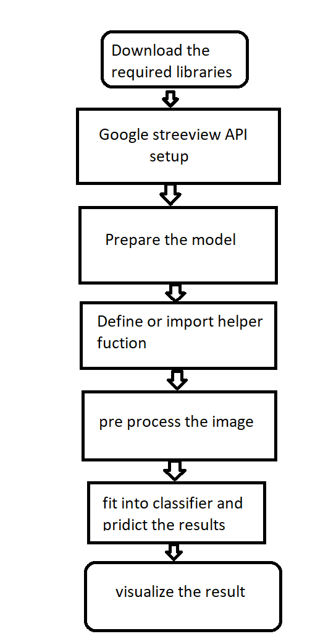

Figure 9 pipeline

Each step-in pipeline is important and need to run sequentially to make the whole script run successfully.

## Download the required libraries

To able to use google streetview API[2] some important libraries like “google-streetview” much be installed first. There are also some other libraries like imguag[35] for image processing and visualizing, pycocotools[36] is a Python API that assists in loading, parsing and visualizing the annotations in COCO[37]. Microsoft COCO is a large image dataset designed for object detection, segmentation, and caption generation.

## Google Street view Api

After downloading the streetview libraries it needs to be imported to use its helper function .For the purpose of project the “ google_streetview.api” and import “google_streetview.helpers” were imported. google_streetview.api module contains list of fuction to download the images and metadata from the links. google_streetview.helpers contains the helper function which is need for debugging and parsing the parameters passed.

Google street view Api gives user many parameters to work with, example of parameters is given below,

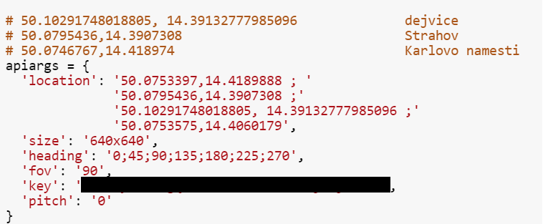

Figure 10 example arguments in Streetview API

Location describes the coordinates of location in form of numbers of latitude, longitude. Multiple location can be fitted in arguments. If no image is available then API will return a generic image with text “Sorry, we have no imagery here."

Size is the resolution of downloaded image. Highest resolution can be downloaded is 2048x2048 which is available with google premium account services. In project standard 640x640 image is used for the classification.

Heading indicated the compass heading of the camera, accepted values are 0 to 360. North is indicated by 0. seven different heading angles were chosen for project cause each angle to have something different scenario along with some similarity with adjacent image makes easy to detect the confused objects.

FOV is set to 90 for the project for optimum setting to avoid pixilation in case of zoom in and to less info per pixel in case of zoom out.

For the privacy purpose the developer key is hidden.

Parameters were chosen on basis will give us the best images with orientation, less noise and perfect fit for our model to test. For ex – having pitch to -90 or 90 gives the images headed up to sky and bottom to floor.

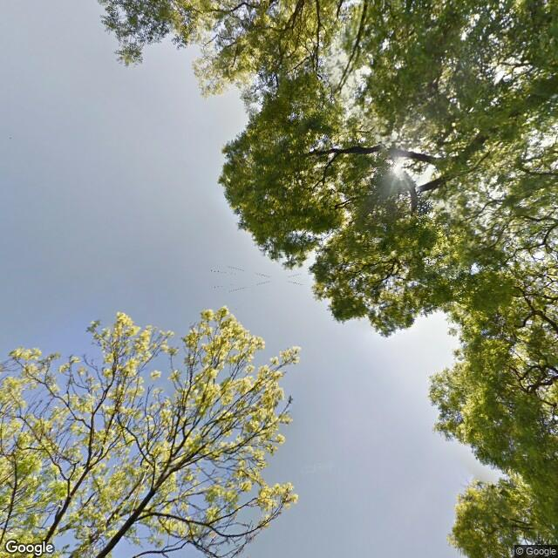

Figure 11 Figure 12pitch with -90

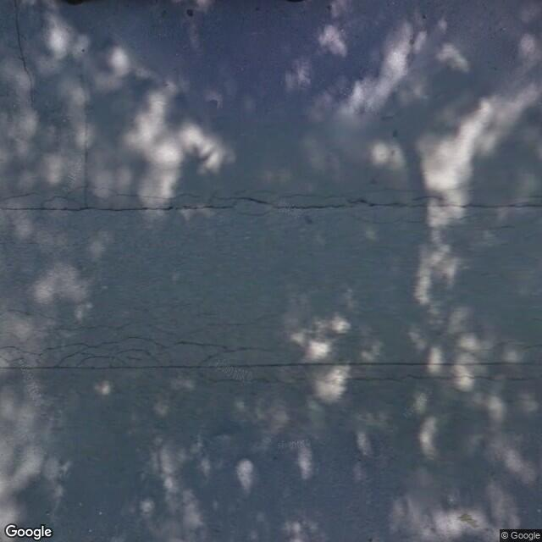

Figure 12 pitch with 90

The task was to find the images which not only consist of normal streets consist of vehicle, traffic lights on which Models were trained but also park, public and general places which can get us the proper evaluation of Detection. To start working with API, it needs to install and import in the script.

## Prepare the model

To use the model with pretrained weights, pre -trained weights should be downloaded. The path for downloaded Image and output image, all import of other basic libraries for visualization, record time are done in this step

## Define or import helper function

Some helper function which can be used for tuning paraments like confidence, number of instances per image, import of class names and labels etc. (in case of Mask R-CNN[3]) should be prepared. Import of all preprocessing tools class names are in this step.

## Preprocess the Image

Images are processed in order to use for classification. Images can be resized, convert to gray scaled etc. before put into classifier. For ex- VGG16[5], VGG19[5], and ResNet50[8] all accept 224×224 input images while Inception V3[7] and Xception[4] require 299×299 pixel inputs which can be easily done with keras[14] helper function easily. Below figure shows the way to do it.

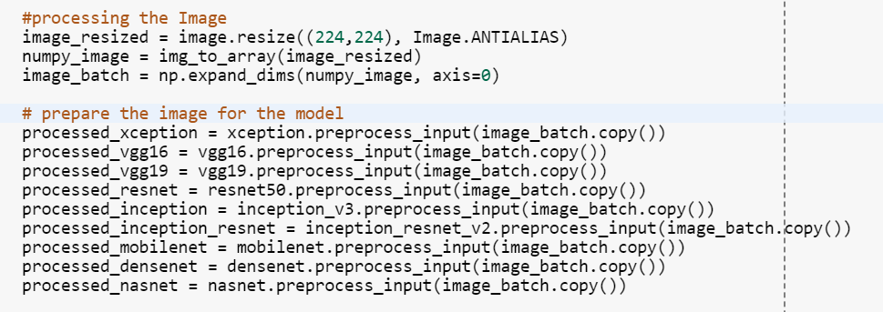

Figure 13 preprocessing of image in Keras

In case of Mask R-CNN[3] it uses 1024x1024 square images in which smallest size is 800px and largest size is trimmed to 1000px.

## Fit into classifier and predict the result

After the Images is preprocessed it can be fitted to classifier without any problem. Use the function predict to get the highest probability of class. Figure 14 shows the example to do prediction. Function return the list of the class names and the confidence rates .

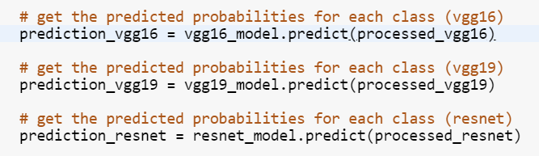

Figure 14 prediction in Keras

In case of Mask R-CNN we fit the image into detect function. It returns class id, masks, scores, region of Interests (bounding boxes).

## Visualize the result

Finally, image is displayed along with score and class names. Figure 15 shows the results from the pre-trained model in keras.

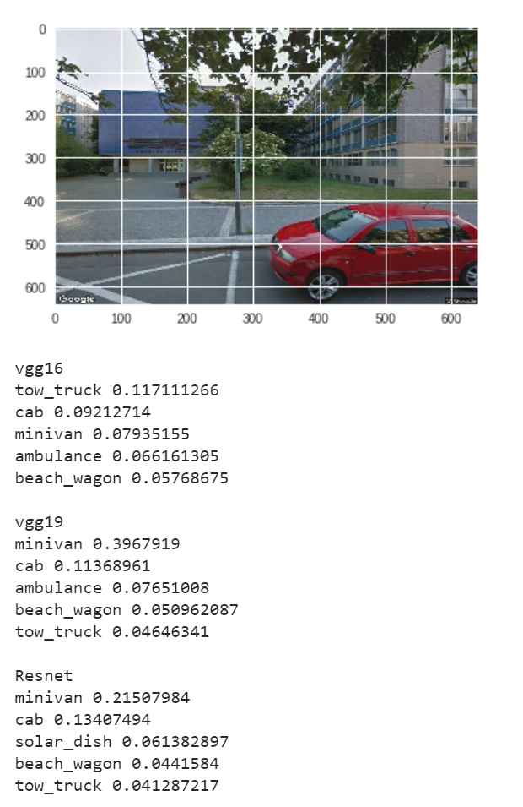

Figure 15 visual result in keras

In Mask R-CNN[3] we get the instance segmentation with class names, confidence, bounding boxes and mask. Figure 16 is example of same image

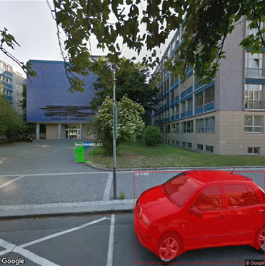

Figure 16 visualization in Mask R-CNN

# **Evaluation**

During the Experimentation with the Mask R-CNN[3] at 3 different location in Prague

1. 50.10291748018805, 14.39132777985096 Dejvice
2. 50.0795436,14.3907308 Strahov
3. 50.0746767,14.418974 Karlovo namesti

With the specified parameters of Google Streetview API[2] in Implementation section total 27 images were downloaded .

With Masck RCNN configuration as

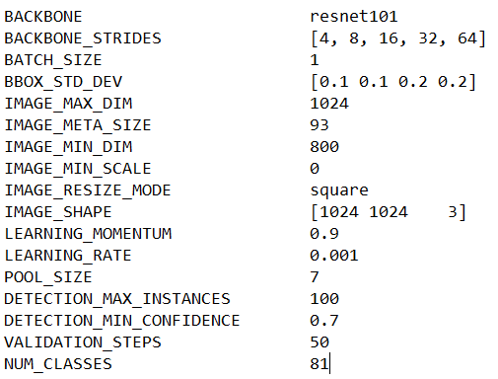

Figure 17 configuration of Mask RCNN

With classes

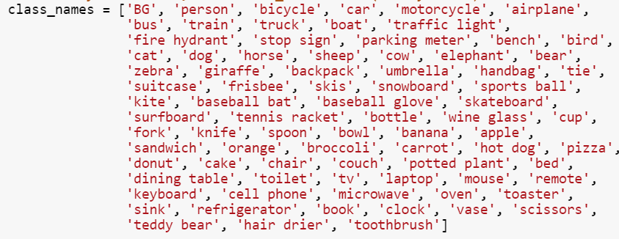

Figure 18 List of Classes

It took 66.32592940330505 sec to complete the classificaton .In which downloading the Images from Google Streetview and pre-trained weight which is of 245 MB were included and downloading neccesary libray like cython ,imguag ,Cython ,google-streetview were excluded in time calculation.

All Images are shown in the Appendix A with there classification with Instance segmentaion along with bounding boxes and confidence and description.

Among all 27 pictures there will correct classification except 8 misclassified objects mentioned in descprition below in Appendix A.

Here are the Results of some Images with in Google Street Downloaded Images which might be interesting to display

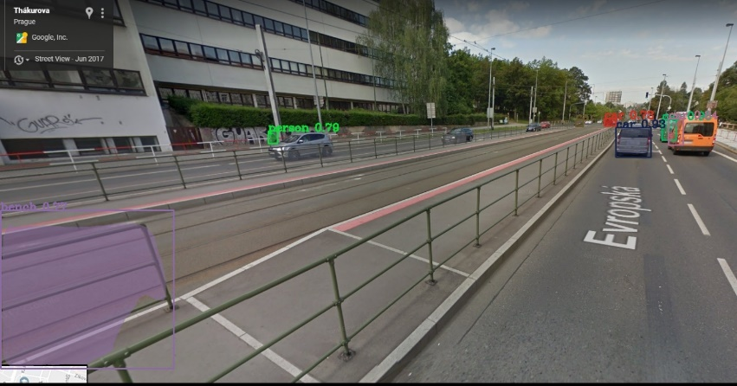

Figure 19

Grill were misclassified as bench

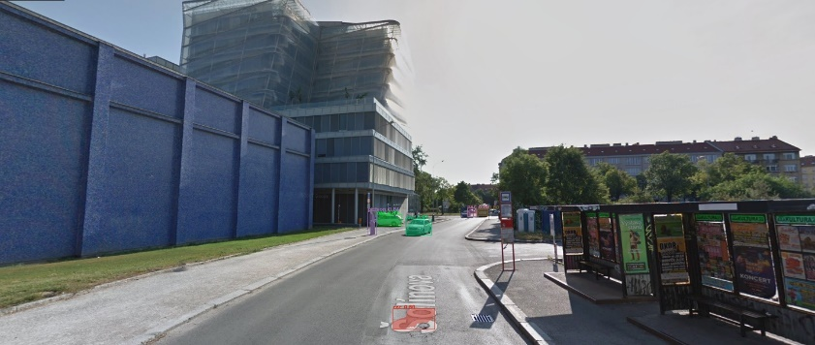

Figure 20

Street name in text classified as car

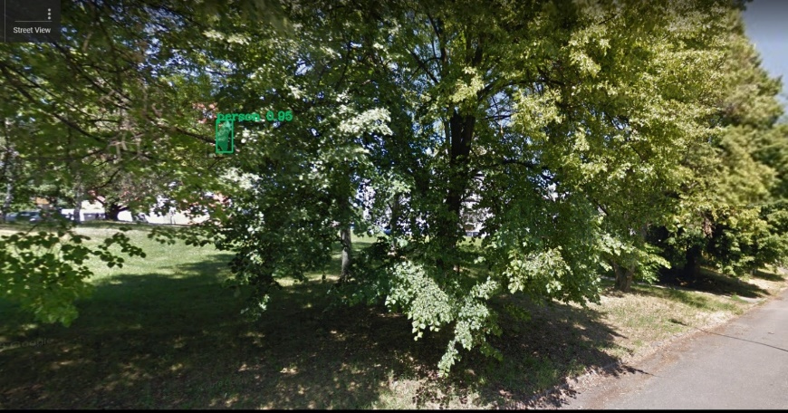

Figure 21

Person in between trees with confidence of 0.95(misclassification)

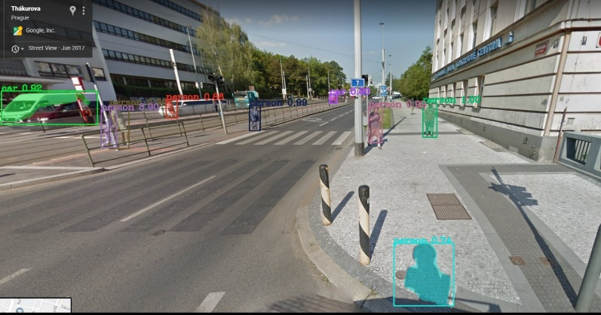

Figure 22

Shadow of fire hydrant classified as person with confidence of 0.71

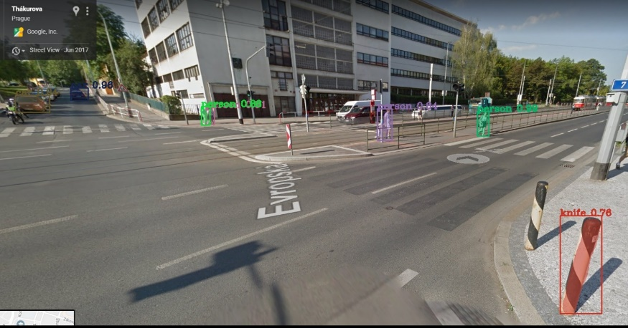

Figure 23

Blocker in streets detected as knife with 0.76 confidence

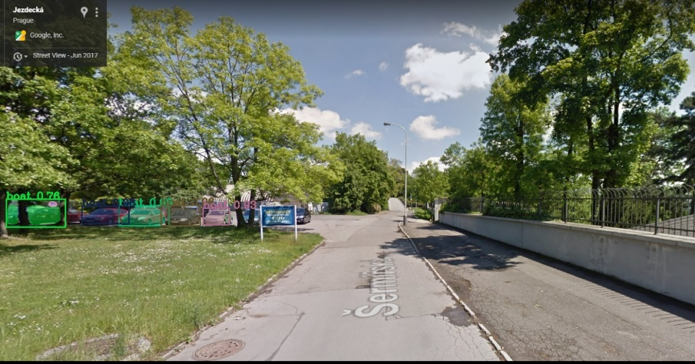

Figure 24

Cars are classified as boat with quite high confidence of 0.93 and 0.76

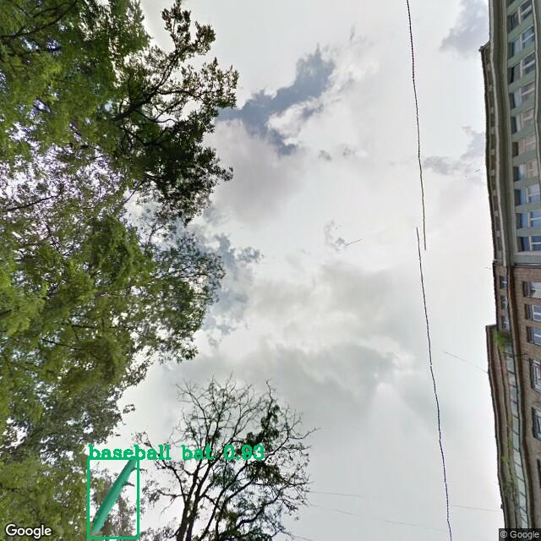

Figure 25

Street pole classified as baseball bat with 0.83 confidence

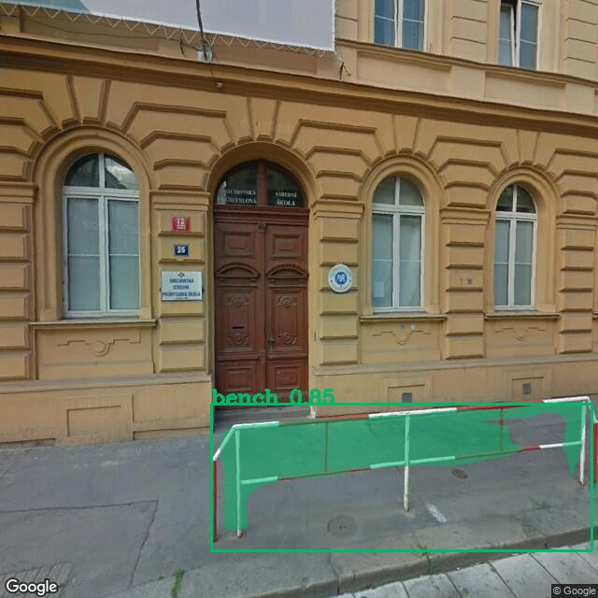

Figure 26

Again road divider grill classified as bench with 0.85

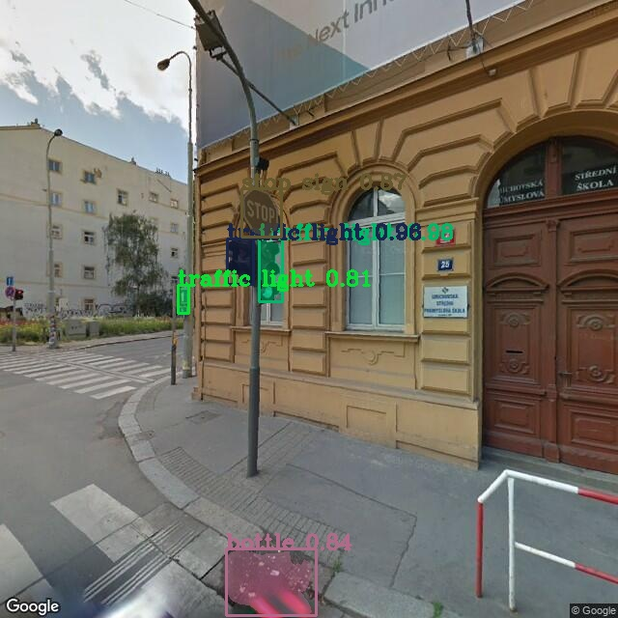

Figure 27

Pit with water classified as Bottle with 0.84

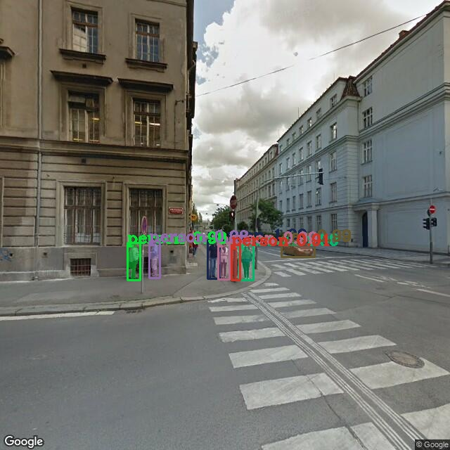

Figure 28

Image with no detection of traffic light which was present in training Data

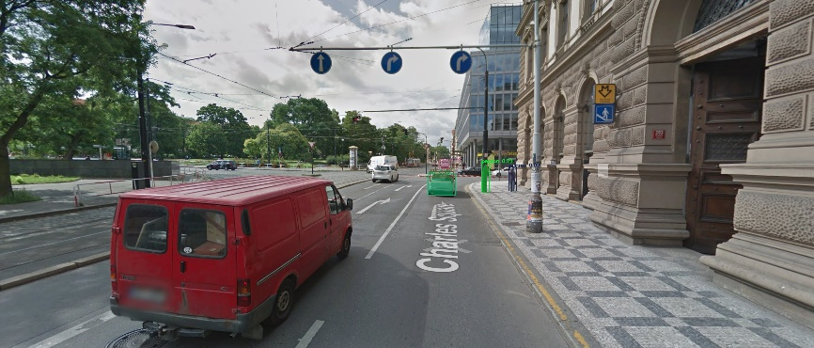

Figure 29

No classification of Car at Instance

Some Classification from Pretrained model in Keras, they give the probability of highest confidence of class in the picture doesn’t support instance segmentation .

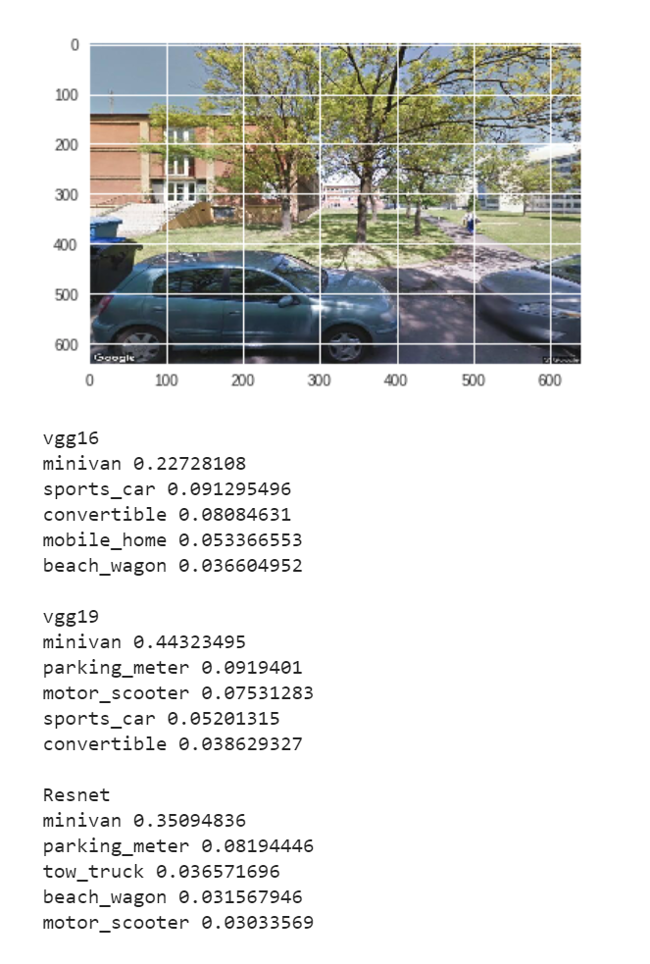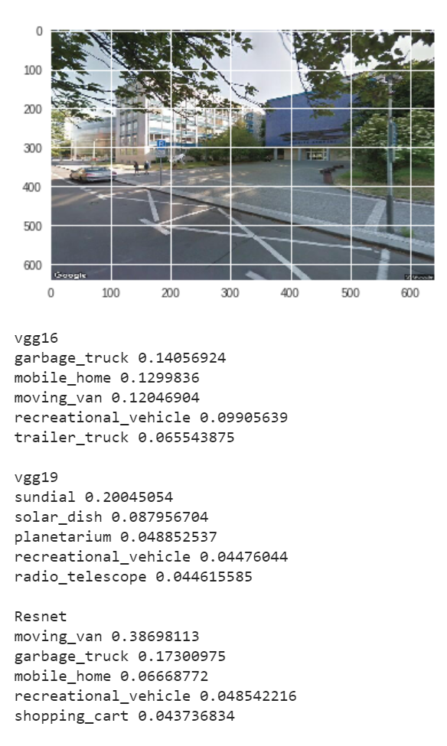

Figure 30 classification by pretrained model

# **Future Scope**

This project will be continued for the master thesis with the aim is to design, implement and experimentally evaluate a deep neural network-based solution for city mapping using Google Street View[2] images. The proposed software solution should allow the user to request Google Street View imagery for any given location specified as geo json, perform analysis and feature extraction using deep neural network(s) and output vectorized description projected and visualized over an underlying map. User interface for the application execution, processing of the input images and visualization of the results should be realized using Google Colab[16] to utilize Google TPUs. Existing pre-trained models should be explored first, thorough experimental evaluation on publicly available datasets should follow. Comparison with related state-of-the-art work is integral part of the work and should be presented in the final thesis. Recommendation: implementation should be done in Python, using Keras[14] and TensorFlow[15] frameworks.

This application will capture images inside of some region and describe about the Imaginary in the maps. All the useful detected objects will be update in the map along with their classes and if possible their dimension and numbers as well. This project can be modified in to various application like defining the safety zone for self-driving cars, change of landscape with time line, perfect timing of route depending on number of traffic signals.

# **Conclusions**

With Aim of project to get software solution which gives the scene description as a list of detected objects and pixel wise scene segmentation in Google street view[2] Imaginary was implemented using Mask RCNN[3] cause of its architecture of performing classification of multiple instance with instance segmentation. Due to incapability classification of multiple objects in single picture and instance segmentation, the other mentioned neural network model couldn’t perform well, though they are still state of the art. The results of classification and segmentation of Google street view was more than expected, Mask RCNN was able to detect roughly 97% (taking 10 instance per image and having 8 misclassified Images) of objects and classify them correctly. Though there were few misclassifications and left out objects (3 objects). The trees and other fine textured objects were able to hallucinate the network sometimes and convert cars into boats (figure 20) and trees into Elephants (figure 45) but results can be still usable.

The implementation of the project with the Google colab[16] was done properly with small changes to developed code. One out of 10 in one time times Google colab crashes and restart itself ,also when using some libraries like OpenCV [28] it crashed more frequently, which can be quite irritation. Some other substitute libraries like mathplot.lib[38] and imguag[35] were more stable and can be used. On the other hand, it provides high end resources like GPU and TPU for free which is quite good for Machine Learning Enthusiast.

This project will be extended as the mater thesis with more scope as described in the future scope section with the complete software solution with combination of data science and user Interface.

# **References**

[1] O. Russakovsky *et al.*, “ImageNet Large Scale Visual Recognition Challenge,” *Int. J. Comput. Vis.*, vol. 115, no. 3, pp. 211–252, 2015.

[2] developers.google.com, “Developer Guide,” *December 19, 2018.*, 2018. [Online]. Available: https://developers.google.com/maps/documentation/streetview/intro.

[3] K. He, G. Gkioxari, P. Dollar, and R. Girshick, “Mask R-CNN,” *Proc. IEEE Int. Conf. Comput. Vis.*, vol. 2017–Octob, pp. 2980–2988, 2017.

[4] F. Chollet, “Xception: Deep learning with depthwise separable convolutions,” *Proc. - 30th IEEE Conf. Comput. Vis. Pattern Recognition, CVPR 2017*, vol. 2017–Janua, pp. 1800–1807, 2017.

[5] K. Simonyan and A. Zisserman, “Very Deep Convolutional Networks for Large-Scale Image Recognition,” *Am. J. Heal. Pharm.*, vol. 75, no. 6, pp. 398–406, Sep. 2014.

[6] C. Szegedy, V. Vanhoucke, S. Ioffe, J. Shlens, and Z. Wojna, “Rethinking the Inception Architecture for Computer Vision,” 2015.

[7] C. Szegedy, S. Ioffe, V. Vanhoucke, and A. Alemi, “Inception-v4, Inception-ResNet and the Impact of Residual Connections on Learning,” *J. Urol.*, vol. 131, no. 2, pp. 262–263, Feb. 2016.

[8] K. He, X. Zhang, S. Ren, and J. Sun, “Deep Residual Learning for Image Recognition,” *Enzyme Microb. Technol.*, vol. 19, no. 2, pp. 107–117, Dec. 2015.

[9] A. G. Howard *et al.*, “MobileNets: Efficient Convolutional Neural Networks for Mobile Vision Applications,” 2017.

[10] M. Sandler, A. Howard, M. Zhu, A. Zhmoginov, and L.-C. Chen, “MobileNetV2: Inverted Residuals and Linear Bottlenecks,” 2018.

[11] G. Huang, Z. Liu, L. Van Der Maaten, and K. Q. Weinberger, “Densely connected convolutional networks,” *Proc. - 30th IEEE Conf. Comput. Vis. Pattern Recognition, CVPR 2017*, vol. 2017–Janua, pp. 2261–2269, 2017.

[12] B. Zoph and J. Shlens, “Learning Transferable Architectures for Scalable Image Recognition.”

[13] Python Software Foundation, “Python,” 2019. [Online]. Available: https://www.python.org/about/.

[14] “Keras Documentation,” 2019. [Online]. Available: https://keras.io/.

[15] “TensorFLow.” [Online]. Available: https://www.tensorflow.org/guide.

[16] Colab.research.google.com, “Welcome to Colaboratory!” [Online]. Available: https://colab.research.google.com/notebooks/welcome.ipynb.

[17] S. F. Conservancy, “git --fast-version-control.” [Online]. Available: https://git-scm.com/site.

[18] C. Michaelis, I. Ustyuzhaninov, M. Bethge, and A. S. Ecker, “One-Shot Instance Segmentation,” 2018.

[19] en.wikipedia.org, “Contextual Image classification,” *2018*. [Online]. Available: https://en.wikipedia.org/wiki/Contextual_image_classification.

[20] Http://cs231n.stanford.edu/, “Image Classification.” [Online]. Available: http://cs231n.github.io/classification/.

[21] G. Stockman and L. G. Shapiro, *Computer Vision*, 1st ed. Upper Saddle River, NJ, USA: Prentice Hall PTR, 2001.

[22] N. Valigi, “A review of deep learning models for semantic segmentation,” 2016. [Online]. Available: https://nicolovaligi.com/deep-learning-models-semantic-segmentation.html.

[23] H. Y. Kim and B. R. Kang, “Instance Segmentation and Object Detection with Bounding Shape Masks,” 2018.

[24] Stanford Vision Lab, “Large Scale Visual Recognition Challenge (ILSVRC),” 2015. [Online]. Available: http://www.image-net.org/challenges/LSVRC/.

[25] A. Rosebrock, “ImageNet: VGGNet, ResNet, Inception, and Xception with Keras,” 2017. [Online]. Available: https://www.pyimagesearch.com/2017/03/20/imagenet-vggnet-resnet-inception-xception-keras/.

[26] jupyter.org, “Documentation,” 2019. [Online]. Available: https://jupyter.org/documentation.

[27] Pytorch.org, “PYTORCH DOCUMENTATION,” 2018. [Online]. Available: https://pytorch.org/docs/stable/index.html.

[28] I. Culjak, D. Abram, T. Pribanic, H. Dzapo, and M. Cifrek, “A brief introduction to OpenCV,” *MIPRO, 2012 Proc. 35th Int. Conv.*, pp. 1725–1730, 2012.

[29] S. Ren, K. He, R. B. Girshick, and J. Sun, “Faster {R-CNN:} Towards Real-Time Object Detection with Region Proposal Networks,” *CoRR*, vol. abs/1506.01497, 2015.

[30] R. Girshick, “Fast R-CNN,” *Proc. IEEE Int. Conf. Comput. Vis.*, vol. 2015 International Conference on Computer Vision, ICCV 2015, pp. 1440–1448, 2015.

[31] en.wikipedia.org, “Bilinear interpolation,” 2019. [Online]. Available: https://en.wikipedia.org/wiki/Bilinear_interpolation.

[32] T. Y. Lin, P. Dollár, R. Girshick, K. He, B. Hariharan, and S. Belongie, “Feature pyramid networks for object detection,” *Proc. - 30th IEEE Conf. Comput. Vis. Pattern Recognition, CVPR 2017*, vol. 2017–January, pp. 936–944, 2017.

[33] M.-Y. Liu, S. Lin, S. Ramalingam, and O. Tuzel, “Layered Interpretation of Street View Images,” 2015.

[34] J. Kang, M. Körner, Y. Wang, H. Taubenböck, and X. X. Zhu, “Building instance classification using street view images,” *ISPRS J. Photogramm. Remote Sens.*, vol. 145, pp. 44–59, 2018.

[35] A. Jung, “imguag Documentation,” 2017. [Online]. Available: https://imgaug.readthedocs.io/en/latest/source/installation.html.

[36] Public, “pycocoapi,” 2018. [Online]. Available: https://github.com/cocodataset/cocoapi/blob/master/PythonAPI/pycocotools/coco.py.

[37] T.-Y. Lin *et al.*, “Microsoft {COCO:} Common Objects in Context,” *CoRR*, vol. abs/1405.0312, 2014.

[38] M. D. John Hunter, Darren Dale, Eric Firing, “Matplotlib,” 2012. [Online]. Available: https://matplotlib.org/.

# **Appendix A**

All processed Images after the classification and segmentation. Pictures are intentionally scaled bigger for understanding of the user

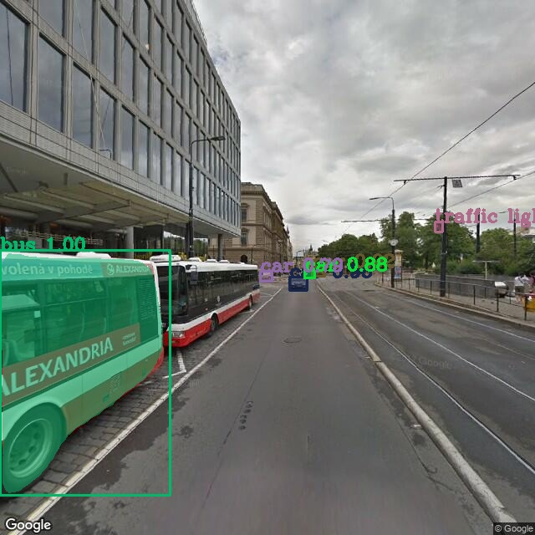

Figure 31

Almost perfect detection of all the detected object with one bus missing for classification. Detected class were bus, car, traffic lights.

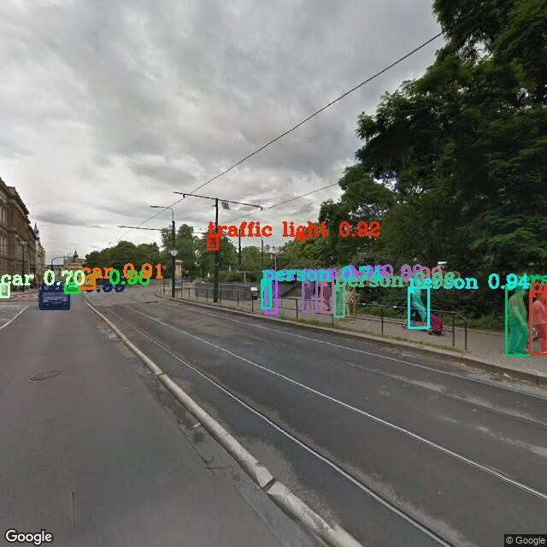

Figure 32

Typical scenario of city streets with detection of almost everything with class person, traffic light and cars.

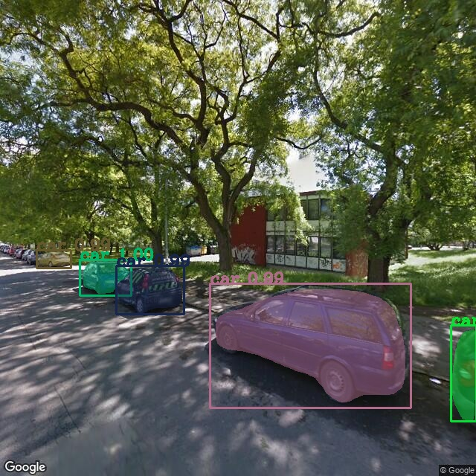

Figure 33

Situation of street with trees where there are high chances of failing in classification due to too much texture in trees and shadows but still able to detect and accurate segmentation of cars.

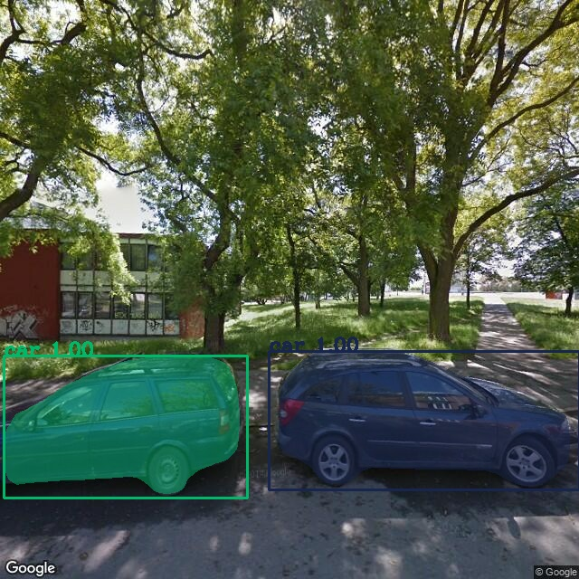

Figure 34

Detection of class car with full confidence

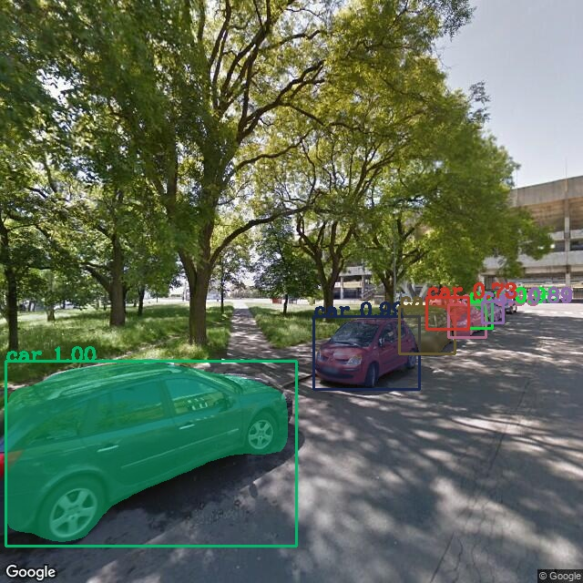

Figure 35

Detection of almost all important classes with good confidence

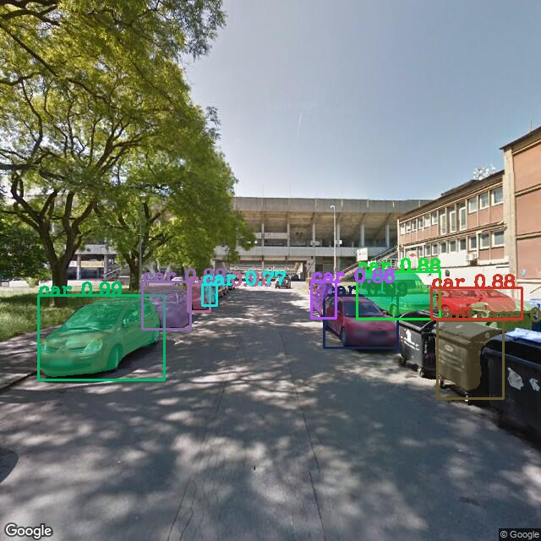

Figure 36

Almost perfect detection of class with one misclassified object of suitcase instead of Trash bin

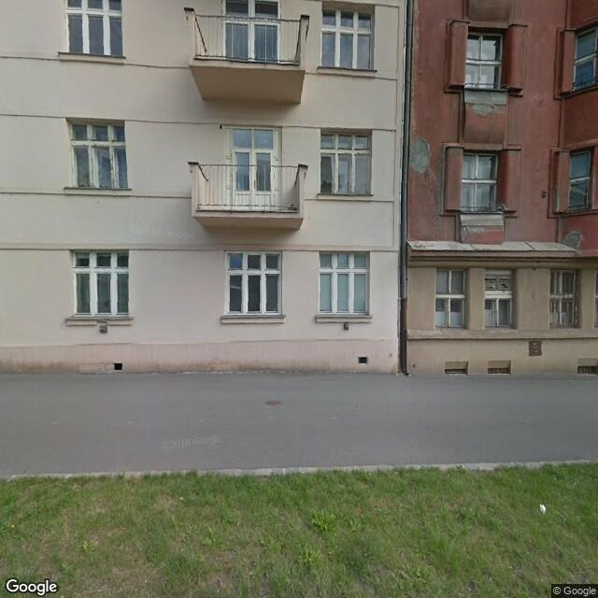

Figure 37

No obejects detected which is okay cause noting can be find from the specified classes

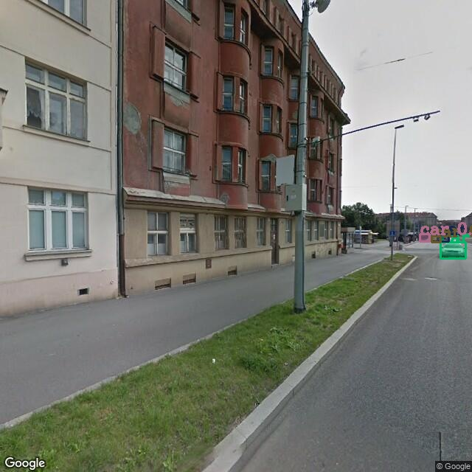

Figure 38

Again, correct classification of small images which can be hard for human to recognize

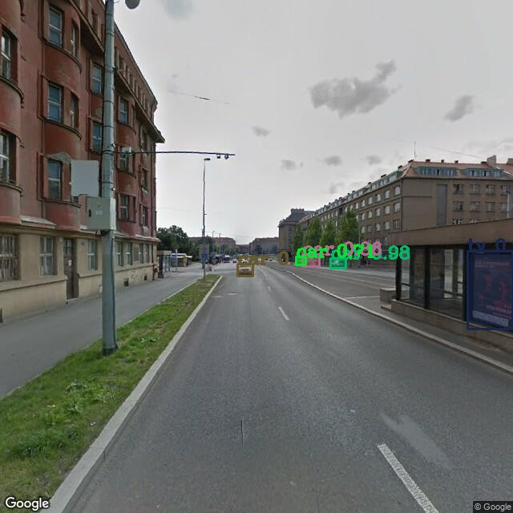

Figure 39

Classification of classes car

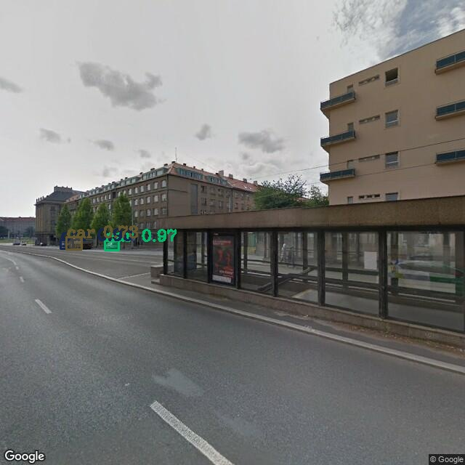

Figure 40

Classification of objects far away

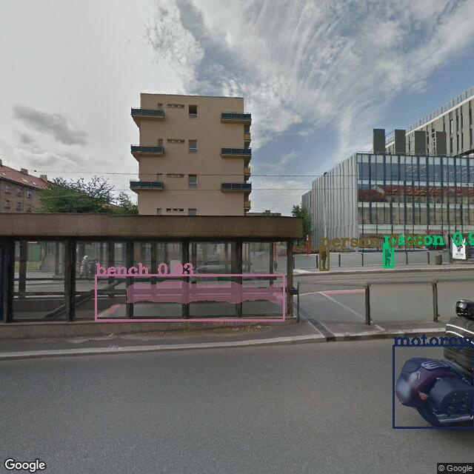

Figure 41

Correct classification of back of motorcycle but misclassification of grill as bench.

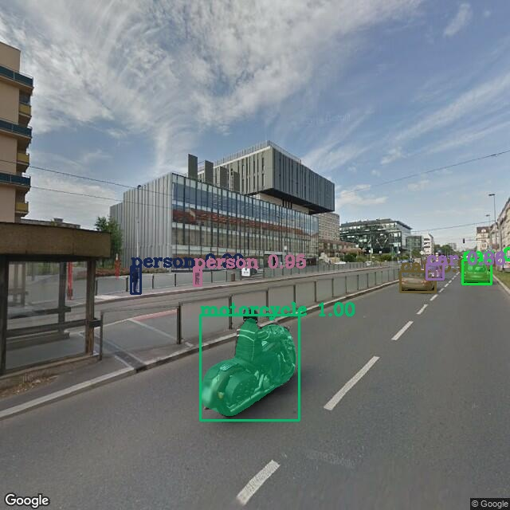

Figure 42

Correct classification of motorcycle but didn’t able to classify the person on it. The persons around were classified correctly.

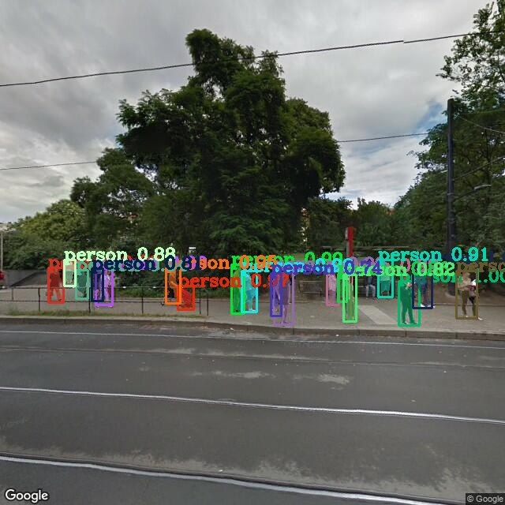

Figure 43

Correct classification of every detected objects.

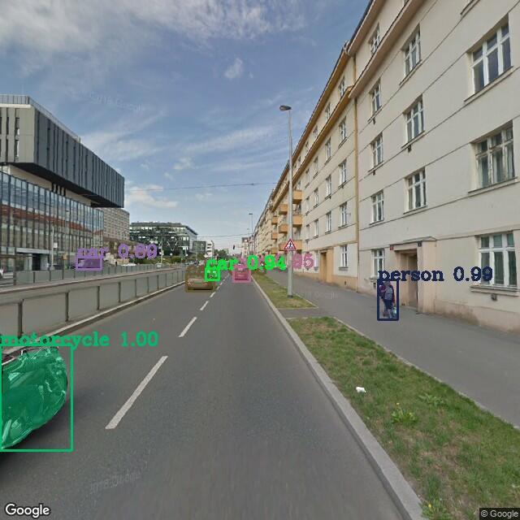

Figure 44

Correct classification of all the classes

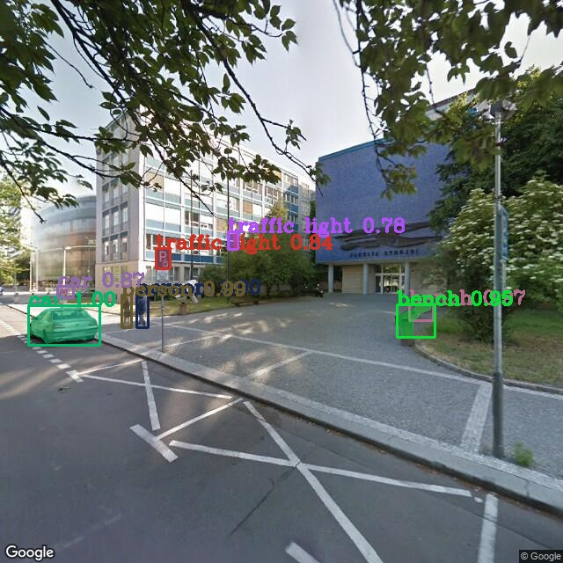

Figure 45

Correct classification of bench, car and person but misclassification of traffic lights

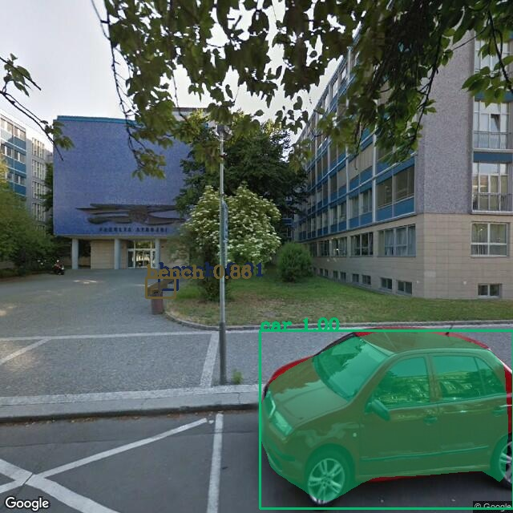

Figure 46

Correct classified of classes

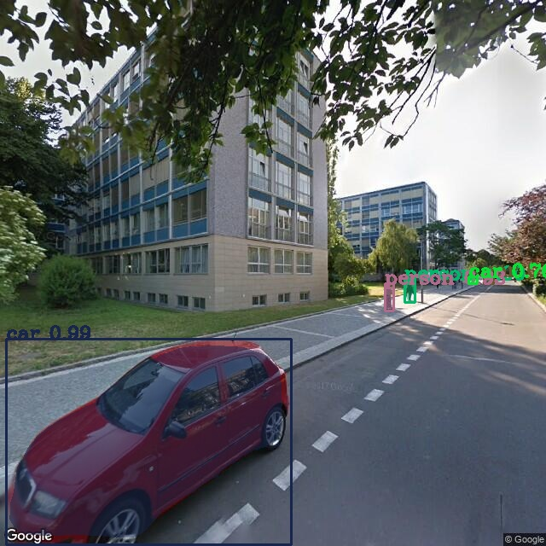

Figure 47

Person and car are classified

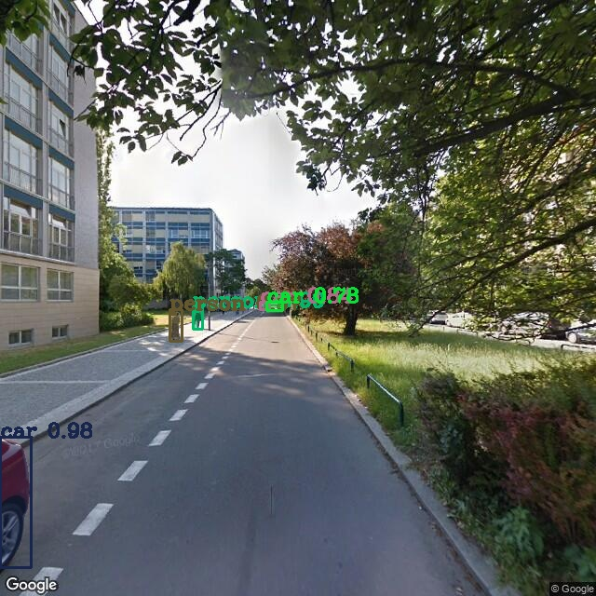

Figure 48

Correct detection of car just by the wheel, correct classification of person too.

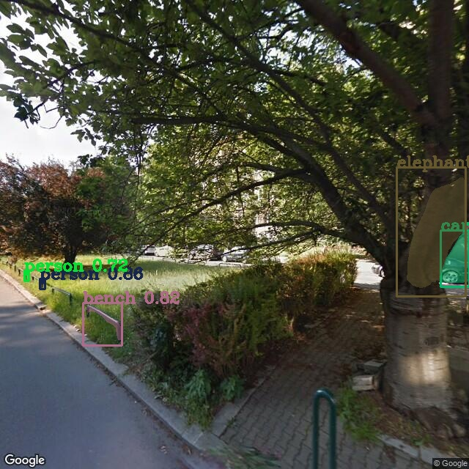

Figure 49

Too many misclassified objects, it include person, bench and elephant class. Only correct classification is car.

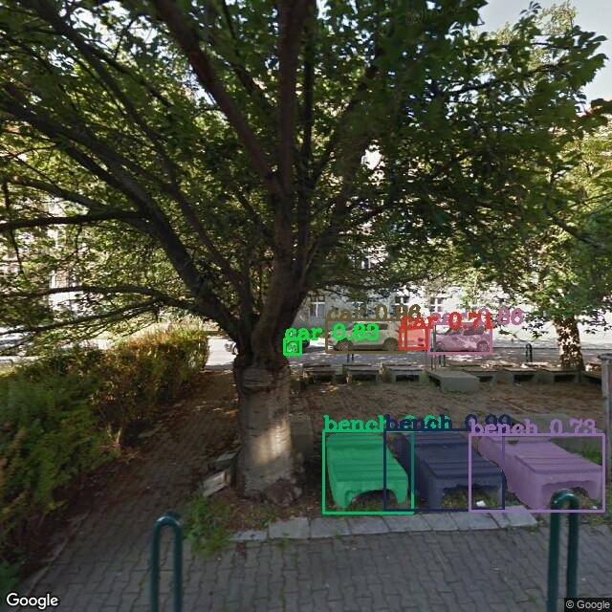

Figure 50

Correct classification of objects.

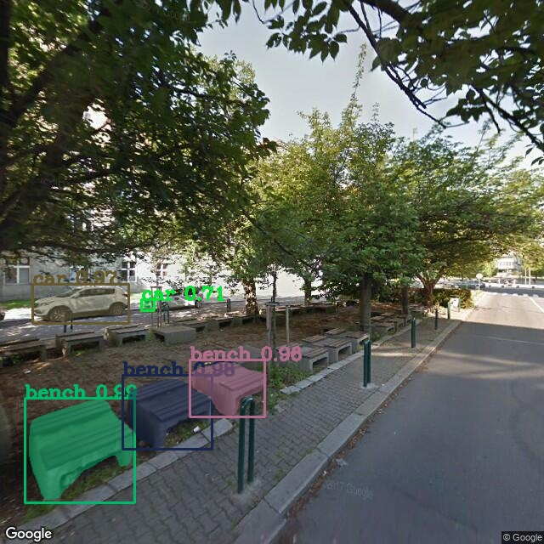

Figure 51

Correct classification of classes

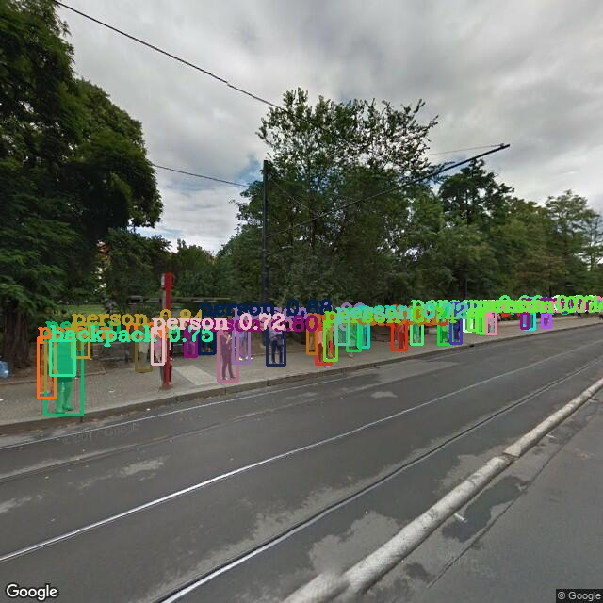

Figure 52

Too typical image even for human to evaluate, but still almost all classification and segmentation are correct.

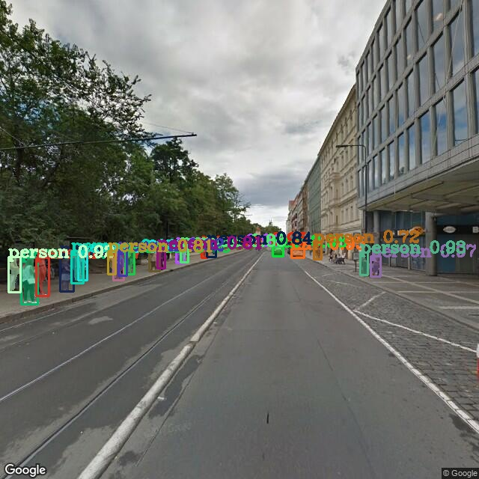

Figure 53

Almost all persons were classified

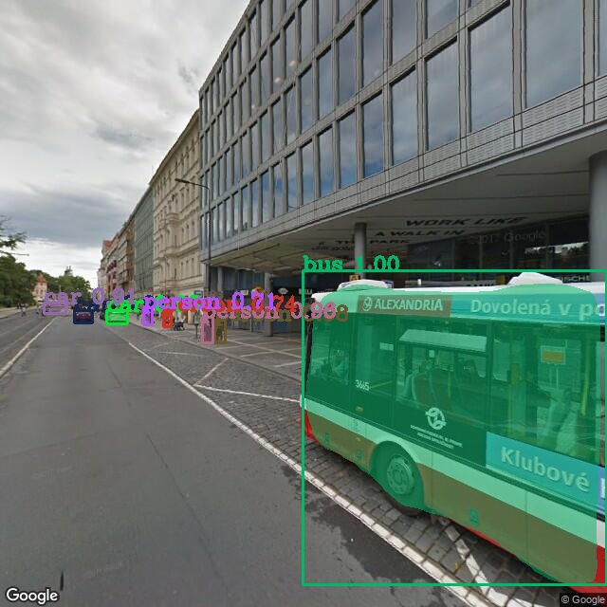

Figure 54

Correct classification of objects

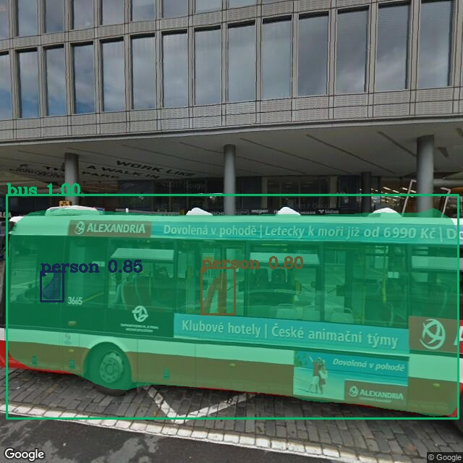

Figure 55

Classification of person inside bus but the behind one is misclassified

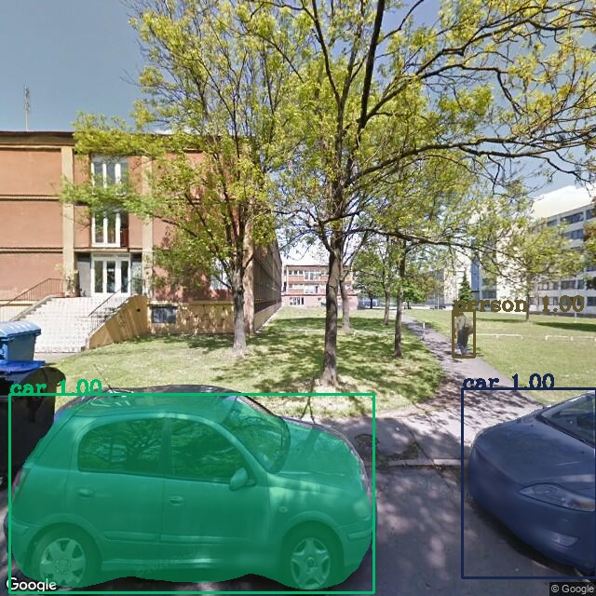

Figure 56

Perfect classification and segmentation

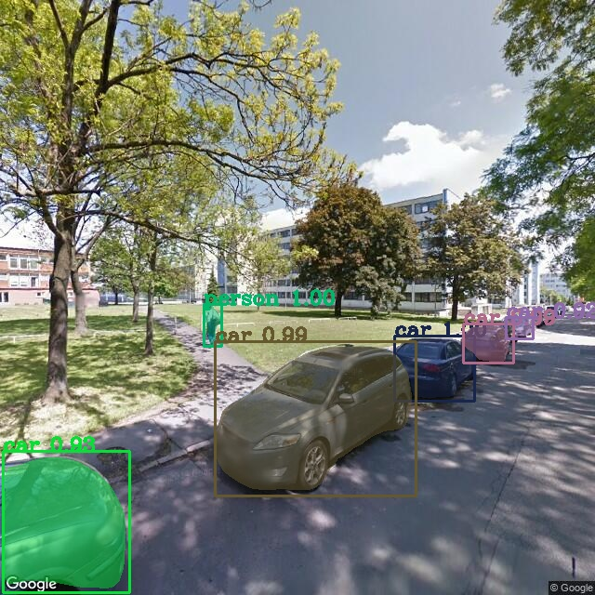

Figure 57

No misclassified object

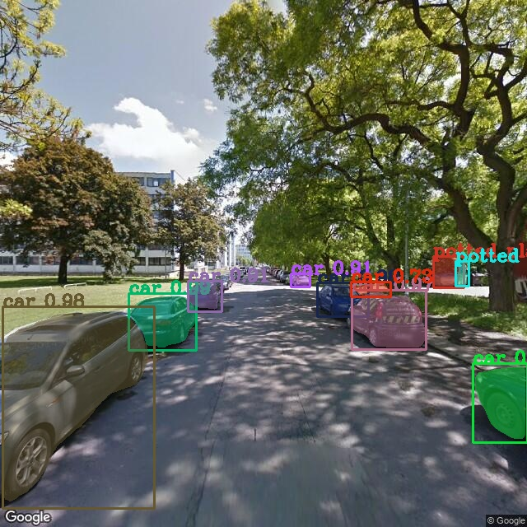

Figure 58

Misclassified potted

# **Appendix B**

Code for pretrained model Masked RCNN

*Automatically generated by Colaboratory.  
  
Original file is located at  
 https://colab.research.google.com/drive/16AIGaLGc_1lHwez0NJ8WF0AnX0VoiDbg  
  
# Install libraries  
"""*!pip install imgaug  
!pip install Cython  
!pip install pycocotools  
!pip install kaggle  
!pip install google-streetview  
  
**"""# ** Google Street api Setup**"""  
  
import** google_streetview.api  
**import** google_streetview.helpers  
  
*# 50.10291748018805, 14.39132777985096 dejvice   
# 50.0795436,14.3907308 Strahov  
# 50.0746767,14.418974 Karlovo namesti*apiargs = {  
 **'location'**: **'50.0753397,14.4189888 ; '  
 '50.0795436,14.3907308 ;'  
 '50.10291748018805, 14.39132777985096 ;'  
 '50.0753575,14.4060179'**,  
 **'size'**: **'640x640'**,  
 **'heading'**: **'0;45;90;135;180;225;270'**,  
 **'fov'**: **'90'**,  
 **'key'**: **'XXXXXXXXXXXXXXXXXXXXXXXXXXX'**,  
 **'pitch'**: **'0'**}  
*# Get a list of all possible queries from multiple parameters*api_list = google_streetview.helpers.api_list(apiargs)  
  
*# Create a results object for all possible queries*resultsg = google_streetview.api.results(api_list)  
  
*# Preview results  
#resultsg.preview()  
  
# Download images to directory 'downloads'*resultsg.download_links(**'StreetImages'**)  
  
*# Save metadata*resultsg.save_metadata(**'metadata.json'**)  
  
**"""# Clone Repo"""**!git clone https://github.com/matterport/Mask_RCNN  
  
**import** os   
os.chdir(**'Mask_RCNN/samples'**)  
  
**"""# Prepare Module"""  
  
import** sys  
**import** random  
**import** math  
**import** numpy **as** np  
**import** skimage.io  
**import** matplotlib  
**import** matplotlib.pyplot **as** plt  
**from** os **import** listdir  
**from** os.path **import** isfile, join  
  
*# Root directory of the project*ROOT_DIR = os.path.abspath(**"../"**)  
  
*# Import Mask RCNN*sys.path.append(ROOT_DIR) *# To find local version of the library***from** mrcnn **import** utils  
**import** mrcnn.model **as** modellib  
**from** mrcnn **import** visualize  
*# Import COCO config*sys.path.append(os.path.join(ROOT_DIR, **"samples/coco/"**)) *# To find local version***import** coco  
  
*# %matplotlib inline   
  
# Directory to save logs and trained model*MODEL_DIR = os.path.join(ROOT_DIR, **"logs"**)  
  
*# Local path to trained weights file*COCO_MODEL_PATH = os.path.join(ROOT_DIR, **"mask_rcnn_coco.h5"**)  
*# Download COCO trained weights from Releases if needed***if not** os.path.exists(COCO_MODEL_PATH):  
 utils.download_trained_weights(COCO_MODEL_PATH)  
  
*# Directory of images to run detection on  
#IMAGE_DIR = 'downlaods'*IMAGE_DIR = **'/content/StreetImages'**print(IMAGE_DIR)  
print(ROOT_DIR)  
  
**"""# Some helper fuctions"""  
  
def** random_colors(N):  
 np.random.seed(1)  
 colors = [tuple(255 * np.random.rand(3)) **for** _ **in** range(N)]  
 **return** colors  
   
**def** display_instances(image, boxes, masks, ids, names, scores):  
 *"""  
 take the image and results and apply the mask, box, and Label  
 """* n_instances = boxes.shape[0]  
 colors = random_colors(n_instances)  
  
**"""# Create Inference Object"""  
  
class** InferenceConfig(coco.CocoConfig):  
 *# Set batch size to 1 since we'll be running inference on  
 # one image at a time. Batch size = GPU_COUNT * IMAGES_PER_GPU* GPU_COUNT = 1  
 IMAGES_PER_GPU = 1  
  
config = InferenceConfig()  
config.display()  
  
*# Create model object in inference mode.*model = modellib.MaskRCNN(mode=**"inference"**, model_dir=MODEL_DIR, config=config)  
  
*# Load weights trained on MS-COCO*model.load_weights(COCO_MODEL_PATH, by_name=**True**)  
  
*# COCO Class names  
# Index of the class in the list is its ID. For example, to get ID of  
# the teddy bear class, use: class_names.index('teddy bear')*class_names = [**'BG'**, **'person'**, **'bicycle'**, **'car'**, **'motorcycle'**, **'airplane'**,  
 **'bus'**, **'train'**, **'truck'**, **'boat'**, **'traffic light'**,  
 **'fire hydrant'**, **'stop sign'**, **'parking meter'**, **'bench'**, **'bird'**,  
 **'cat'**, **'dog'**, **'horse'**, **'sheep'**, **'cow'**, **'elephant'**, **'bear'**,  
 **'zebra'**, **'giraffe'**, **'backpack'**, **'umbrella'**, **'handbag'**, **'tie'**,  
 **'suitcase'**, **'frisbee'**, **'skis'**, **'snowboard'**, **'sports ball'**,  
 **'kite'**, **'baseball bat'**, **'baseball glove'**, **'skateboard'**,  
 **'surfboard'**, **'tennis racket'**, **'bottle'**, **'wine glass'**, **'cup'**,  
 **'fork'**, **'knife'**, **'spoon'**, **'bowl'**, **'banana'**, **'apple'**,  
 **'sandwich'**, **'orange'**, **'broccoli'**, **'carrot'**, **'hot dog'**, **'pizza'**,  
 **'donut'**, **'cake'**, **'chair'**, **'couch'**, **'potted plant'**, **'bed'**,  
 **'dining table'**, **'toilet'**, **'tv'**, **'laptop'**, **'mouse'**, **'remote'**,  
 **'keyboard'**, **'cell phone'**, **'microwave'**, **'oven'**, **'toaster'**,  
 **'sink'**, **'refrigerator'**, **'book'**, **'clock'**, **'vase'**, **'scissors'**,  
 **'teddy bear'**, **'hair drier'**, **'toothbrush'**]  
  
**"""# Prediction and Visualization"""***# Load image from the images folder*file_names = next(os.walk(IMAGE_DIR))[2]  
procimg = np.empty(len(file_names), dtype=object)  
*#print(file_names)***for** n **in** range(0, len(file_names)):  
 **if** file_names[n] == **'metadata.json'**:  
 **break**;  
 image = skimage.io.imread(os.path.join(IMAGE_DIR, file_names[n]))  
  
 *# Run detection* results = model.detect([image], verbose=1)  
  
 *# Visualize results* r = results[0]  
 procimg = display_instances(image, r[**'rois'**], r[**'masks'**], r[**'class_ids'**],   
 class_names, r[**'scores'**])  
 visualize.display_instances(image, r[**'rois'**], r[**'masks'**], r[**'class_ids'**],   
 class_names, r[**'scores'**])

Code for Pretrained model available in KERAS

*Automatically generated by Colaboratory.  
  
Original file is located at  
 https://colab.research.google.com/drive/1cT0avReSwNfDYV0EfAgND81s_-JjaXWc  
  
# Loading all model available in Keras  
"""***from** keras.applications **import** xception,vgg16,vgg19,resnet50,inception_v3,inception_resnet_v2,mobilenet,mobilenet_v2,densenet,nasnet  
**import** numpy **as** np  
  
*#Load the Xception model*Xcep_model = xception.Xception(weights=**'imagenet'**)  
  
*# Load the VGG16 model*vgg16_model = vgg16.VGG16(weights=**'imagenet'**)  
  
*#Load the VGG19 model*vgg19_model = vgg19.VGG19(weights = **'imagenet'**)  
  
*# Load the Inception_V3 model*inception_model = inception_v3.InceptionV3(weights=**'imagenet'**)  
  
*# Load the Inception_resner_v2 model*inception_res = inception_resnet_v2.InceptionResNetV2(weights=**'imagenet'**)  
  
*# Load the ResNet50 model*resnet_model = resnet50.ResNet50(weights=**'imagenet'**)  
  
*# Load the MobileNet model*mobilenet_model = mobilenet.MobileNet(weights=**'imagenet'**)  
  
*# Load the MobileNet_v2 model*mobilenet_v2 = mobilenet_v2.MobileNetV2(weights=**'imagenet'**)  
  
*# Load the DenseNet model*densenet_model = densenet.DenseNet201(weights=**'imagenet'**)  
  
*# Load the NASNet model*nasnet_model = nasnet.NASNetLarge(weights=**'imagenet'**)  
  
**"""# ** Google Street api Setup**"""**!pip install google-streetview  
**import** google_streetview.api  
**import** google_streetview.helpers  
  
*# 50.10291748018805, 14.39132777985096 dejvice   
# 50.0795436,14.3907308 Strahov  
# 50.0746767,14.418974 Karlovo namesti*apiargs = {  
 **'location'**: **'50.0753397,14.4189888 ; 50.0795436,14.3907308 ;50.10291748018805, 14.39132777985096'**,  
 **'size'**: **'640x640'**,  
 **'heading'**: **'0;45;90;135;180;225;270'**,  
 **'fov'**: **'90'**,  
 **'key'**: **'XXXXXXXXXXXXXXXXXXXXXXXXXXXXXX'**,  
 **'pitch'**: **'0'**}  
  
*# Get a list of all possible queries from multiple parameters*api_list = google_streetview.helpers.api_list(apiargs)  
  
*# Create a results object for all possible queries*resultsg = google_streetview.api.results(api_list)  
  
*# Preview results  
#resultsg.preview()  
  
# Download images to directory 'downloads'*resultsg.download_links(**'StreetImages'**)  
  
*# Save metadata*resultsg.save_metadata(**'metadata.json'**)  
  
**"""# importing the packages"""  
  
from** keras.preprocessing.image **import** load_img  
**from** keras.preprocessing.image **import** img_to_array  
**from** keras.applications.imagenet_utils **import** decode_predictions  
**import** matplotlib.pyplot **as** plt  
**import** os  
**import** skimage.io  
**from** skimage.transform **import** resize  
**from** PIL **import** Image  
**from** skimage.viewer **import** ImageViewer  
*# %matplotlib inline*IMAGE_DIR = **'/content/StreetImages'  
  
"""# Prediction and visulaizeing the results"""***# Load image from the images folder*file_names = next(os.walk(IMAGE_DIR))[2]  
procimg = np.empty(len(file_names), dtype=object)  
  
*#print(file_names)***for** n **in** range(0, len(file_names)):  
 print(**' '**)  
   
 **if** file_names[n] == **'metadata.json'**:  
 **break**;  
   
 *#Load the image* image1 = skimage.io.imread(os.path.join(IMAGE_DIR, file_names[n]))  
 image = Image.open(os.path.join(IMAGE_DIR, file_names[n]))  
   
 *#processing the Image* image_resized = image.resize((224,224), Image.ANTIALIAS)  
 numpy_image = img_to_array(image_resized)  
 image_batch = np.expand_dims(numpy_image, axis=0)  
   
 *# prepare the image for the VGG model* processed_xception = xception.preprocess_input(image_batch.copy())  
 processed_vgg16 = vgg16.preprocess_input(image_batch.copy())  
 processed_vgg19 = vgg19.preprocess_input(image_batch.copy())  
 processed_resnet = resnet50.preprocess_input(image_batch.copy())   
 processed_inception = inception_v3.preprocess_input(image_batch.copy())  
 processed_inception_resnet = inception_resnet_v2.preprocess_input(image_batch.copy())  
 processed_mobilenet = mobilenet.preprocess_input(image_batch.copy())  
 processed_densenet = densenet.preprocess_input(image_batch.copy())  
 processed_nasnet = nasnet.preprocess_input(image_batch.copy())  
   
*# # get the predicted probabilities for each class (xception)  
# prediction_xception = Xcep_model.predict(processed_xception)  
   
 # get the predicted probabilities for each class (vgg16)* prediction_vgg16 = vgg16_model.predict(processed_vgg16)  
   
 *# get the predicted probabilities for each class (vgg19)* prediction_vgg19 = vgg19_model.predict(processed_vgg19)  
   
 *# get the predicted probabilities for each class (resnet)* prediction_resnet = resnet_model.predict(processed_resnet)  
  
 *#Display Image* plt.imshow(image,interpolation=**'nearest'**, aspect=**'auto'**)  
 plt.show()  
 skimage.io.imshow(image1)  
 plt.show()  
 plt.imshow(image_resized)  
 plt.show()  
 plt.imshow(np.uint8(numpy_image))  
 plt.show()  
 plt.imshow(np.uint8(image_batch[0]))  
 plt.show()  
 plt.imshow(np.uint8(processed_xception[0]))  
 plt.show()   
 plt.imshow(np.uint8(processed_vgg16[0]))  
 plt.show()   
 plt.imshow(np.uint8(processed_vgg19[0]))  
 plt.show()   
 plt.imshow(np.uint8(processed_resnet[0]))  
 plt.show()   
 plt.imshow(np.uint8(processed_inception[0]))  
 plt.show()   
 plt.imshow(np.uint8(processed_inception_resnet[0]))  
 plt.show()   
 plt.imshow(np.uint8(processed_mobilenet[0]))  
 plt.show()   
 plt.imshow(np.uint8(processed_densenet[0]))  
 plt.show()   
 plt.imshow(np.uint8(processed_nasnet[0]))  
 plt.show()   
 *# convert the probabilities to class labels  
 # We will get top 5 predictions which is the default* print(**'Xception'**)  
 **for** prediction **in** decode_predictions(prediction_xception)[0]:  
 print(prediction[1], prediction[2])  
   
 print(**' '**)  
 print(**'vgg16'**)  
   
 **for** prediction **in** decode_predictions(prediction_vgg16)[0]:  
 print(prediction[1], prediction[2])  
   
 print(**' '**)  
 print(**'vgg19'**)  
   
 **for** prediction **in** decode_predictions(prediction_vgg19)[0]:  
 print(prediction[1], prediction[2])  
 print(**' '**)  
   
 print(**'Resnet'**)  
 **for** prediction **in** decode_predictions(prediction_resnet)[0]:  
 print(prediction[1], prediction[2])  
   
 print(**' '**)  
  
 print(**'Xception'**)  
 **for** prediction **in** decode_predictions(prediction_xception)[0]:  
 print(prediction[1], prediction[2])  
   
 print(**' '**)

# **List of Figures**

Figure 1 Example of Image classification 7

Figure 2 Example of Image segmentation source:[22] 7

Figure 3 Instance Segmentation 8

Figure 4 Loading of Different models in Keras 9

Figure 5 Micro Architecture of Resnet50 source [25] 10

Figure 6 Head Architecture of Mask R-CNN source [3] 12

Figure 7 Glitches in google Images 13

Figure 8 unproper results without proper parameter values 13

Figure 9 pipeline 15

Figure 10 example arguments in Streetview API 16

Figure 11 Figure 12pitch with -90 16

Figure 12 pitch with 90 17

Figure 13 preprocessing of image in Keras 17

Figure 14 prediction in Keras 18

Figure 15 visual result in keras 18

Figure 16 visualization in Mask R-CNN 19

Figure 17 configuration of Mask RCNN 20

Figure 18 List of Classes 20

Figure 19-29 Images of Intrest 21-26

Figure 30 classification by pretrained model 26

Figure 31 -58 All processed Images 31-58